Syed Muzahir Abbas Naqvi

121181  BSCS-5A

LAB 2 - report

# Introduction:

This Is a report for my lab for Advanced Programming, which is a café application based on Java.

# Approach:

I applied all the concepts of object oriented programming in my code, and used JFrame for building my GUI, I updated the frames dynamically for least memory usage instead of making new frames for every new operation, I used ArrayLists usually to store my data and comprehensively applied error handling in my code for wrong inputs, I used maven to build the project, and applied serialization and deserialization techniques to store data effectively on hard drive.

# Learning:

I learned the GUI building process in Java using JFrame, learned how to perform unit testing and how to use maven to build your project. I also learned how to use github and how to profile your project’s memory usage.

# How to Run:

Just open the project in Netbeans or any other IDE and run the project.

# Analysis:

## Profiling results:

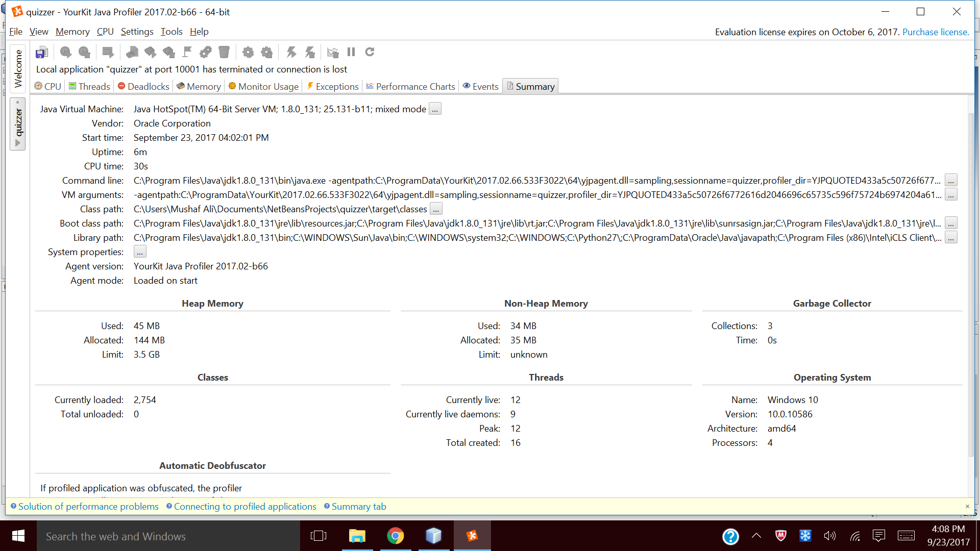

This is a profiling result for the program after running for 6 minutes and adding 2 quizzes which have 10 questions each

# Running program screenshots:

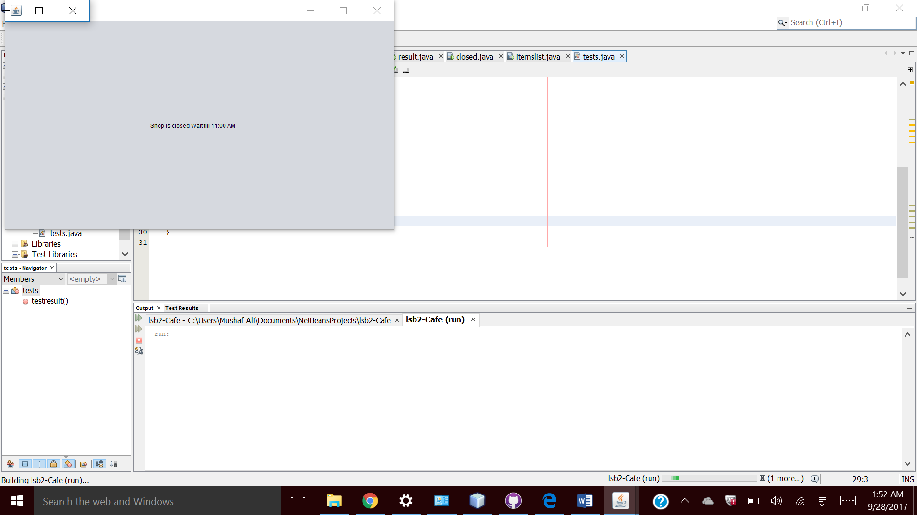

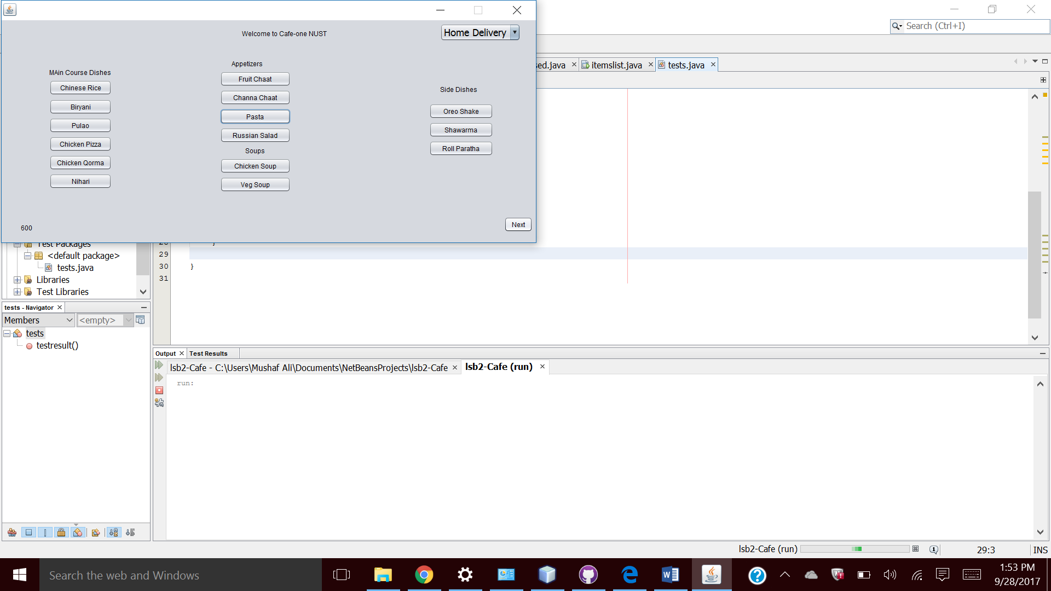

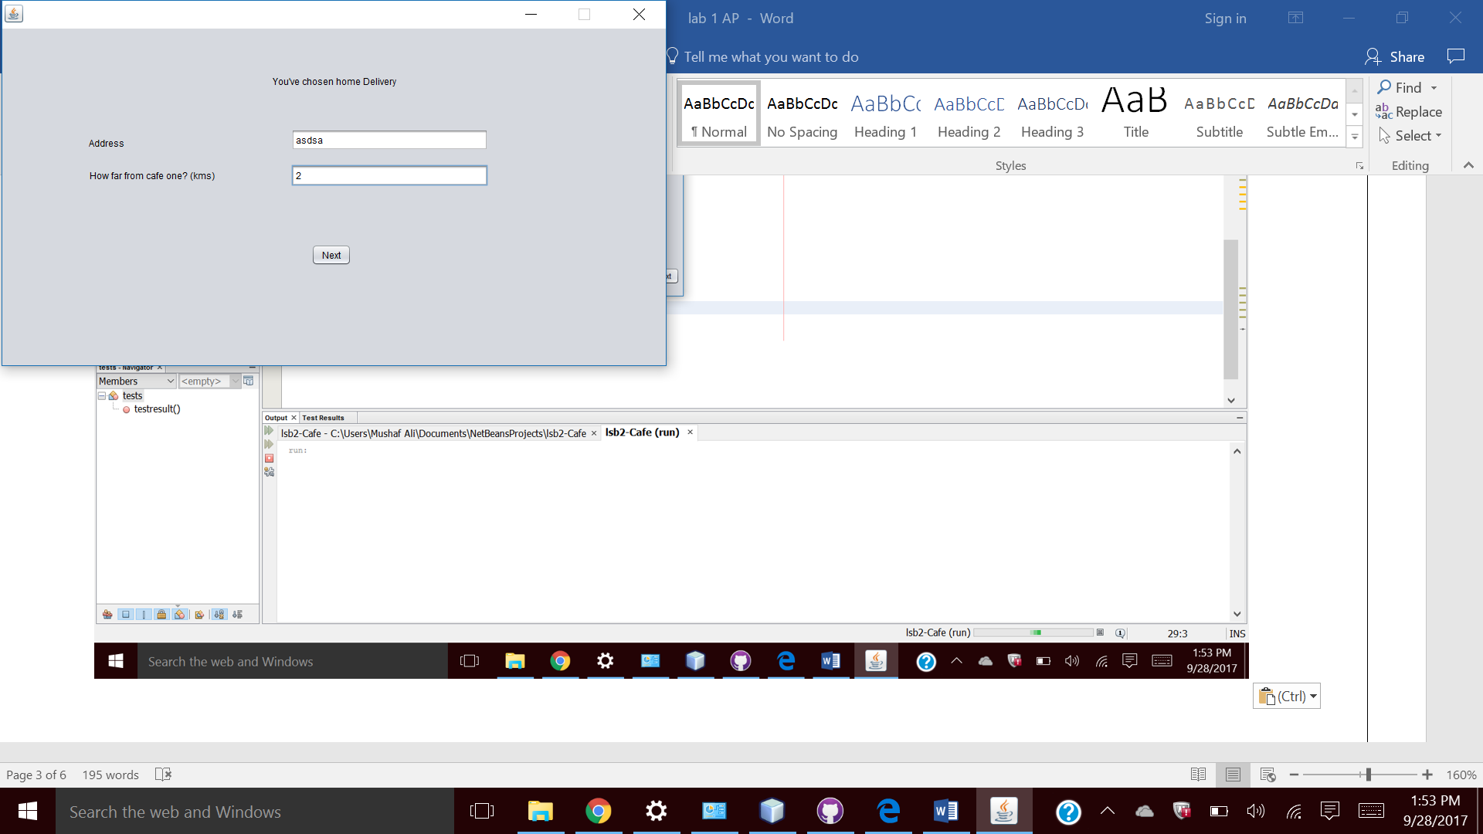

# 

# Unit Tests:

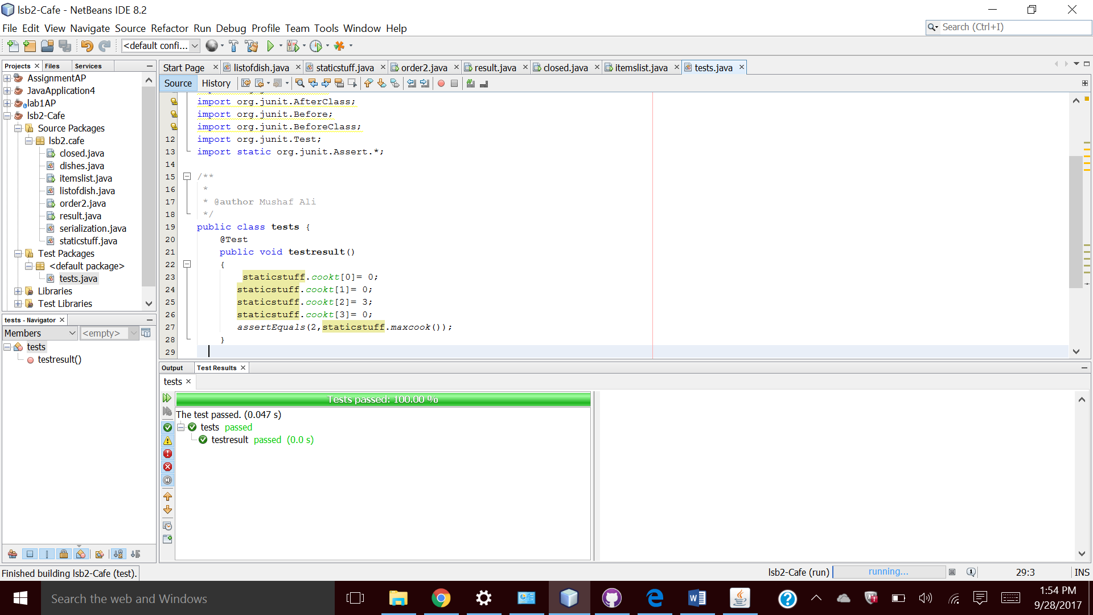

# Github:

